Team Member Names:

Purdue Logins:

Section Number:

Team Number:

Submission Instructions:
- Rename this answer sheet to be Project_M1_Part1-2A_sss_tt.docx where sss is your section number (e.g., 001 for section 001) and tt is your team number (e.g., 07 for team 7).
- Submit this answer sheet along with the answer sheet for Part 2B to the M1 drop box on Bb prior to Class 23.

Notes:
- Only one(1) submission per team
- Only the last submission to the M1 Dropbox will be graded.
  - Make sure Part 1-2A and Part 2B Answer Sheets are all in the last submission.
  - Check to make sure the files can be accessed after uploading to Blackboard.
- After submission, distribute the submitted files to all team members. Ensure all members of the team have copies of the submitted files.

M1 Instructions
Parameter identification is about determining model parameters from available data. This milestone requires you to think carefully about different potential parameter identification approaches, the process of using/coding those approaches, and the consequences of those choices. Your assignment is to develop several ideas for fully automated identification of parameters from first-order time history data. You should use evidence-based rationales when evaluating your ideas. In this context, ‘evidence-based’ means you should refer to the graph of the time history provided - where the graph is a proxy for actual time history data, your knowledge of MATLAB, and other trusted sources when evaluating your ideas.
Note: When external sources are used, each must be properly cited with (1) an in-text citation where referenced in the body of the text and (2) a full citation at the end of the document.

Learning Objective (LO): 21.02 Communicate ideas clearly and concisely
Evidence of Proficiency Requires:
- Purpose of communication is clear
- Processes are fully but concisely described
  - All steps are included
  - Assumptions are stated
  - Appropriate technical language is used
  - Clarifying images (e.g., sketches, graphs and/flow charts) are provided (as necessary)
- External research is accompanied by an in-text citation and full reference
Part 1: Brainstorming
Consider the ‘clean’ step response graph below.

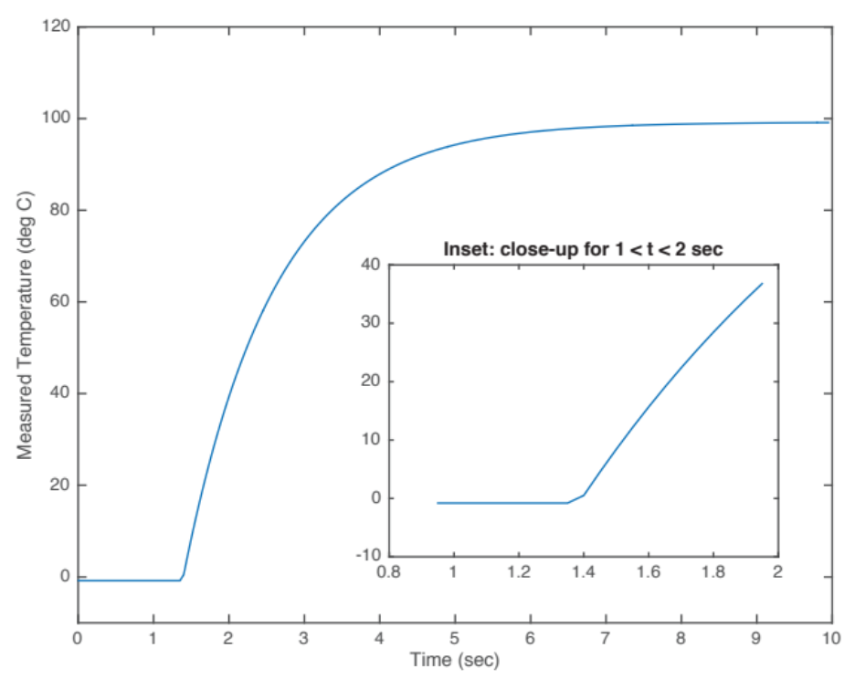

Part 1A. Graphical Approach to Parameter Identification

Use the graph above to identify the key parameters (y_{L}, y_{H,} t_{s}, and τ). State the graphical steps followed and provide sketches on the diagram above to help describe your step (if necessary). Record your parameter results below.

Steps to determine y_{L}
1.
2.
(add more steps as needed)

For the graph above, y_{L} =
Steps to determine y_{H}
1.
2.
(add more steps as needed)

For the graph above, y_{H} =
Steps to determine t_{s},
1.
2.
(add more steps as needed)
For the graph above, t_{s} =
Steps to determine τ
1.
2.
(add more steps as needed)

For the graph above, τ =

Part 1B. Fully Automated Approach to Parameter Identification

Learning Objective (LO): 21.01 Employ idea generation strategies to produce multiple clear, unique, and problem-focused ideas
Evidence of Proficiency Requires:
- Multiple ideas are generated to provide choice during idea reduction
- Ideas generated are clearly described using appropriate technical language and clarifying images (as necessary)
- Ideas generated are clearly different from each other
- Ideas generated are clearly related to the problem posed and reflect an understanding of the problem context
- Ideas linked to external research are accompanied by an in-text citation and full reference

For a fully automated process, you will work with step-response time history data, not graphical representations. For this brainstorming step, refer to the step-response graph with ‘clean’ data above – as a proxy for actual time history data. Generate at least 10 different ideas for identifying the key parameters (y_{L}, y_{H,} t_{s}, and τ) from a ‘clean’ step-response time history data (1 idea for y_{L}, 1 idea for y_{H,} 4 ideas for t_{s}, and 4 ideas for τ).

Right now, you should not attempt to evaluate the quality of your ideas. However, your ideas must be clearly described so that someone not on your team can interpret them. Make sketches on the graph as necessary to explain the ideas you describe in the table below. As appropriate and necessary, copy and paste the image above and use Word draw tools to clarify your ideas.

Brief description of idea for y_{L}
1.
Brief description of idea for y_{H}
1.
Brief description of idea for t_{s}
1.
2.
3.
4.
Brief description of idea for τ
1.
2.
3.
4.

Part 2: Evaluation of Your Ideas
Learning Objective (LO): 21.03 Evaluate model or algorithm development (e.g. ideas, work, functionality) using evidence-based rationales
Evidence of Proficiency Requires:
- Assumptions, claims, and critical decisions are clearly stated
- An appropriate source of evidence is used to support assumptions, claims, and critical decisions
- The evidence is clearly articulated
- External research is accompanied by an in-text citation and full reference

Section A: Clean Data
The ‘clean’ data was derived using equation (1) from the project description document. This data was generated using the time vector time = 0:0.05:10.0. For this part, you will use ideas from Part 1B to identify the parameters t_{s} and τ (assuming that y_{L} and y_{H} are known). Fill out the table below with the details of two approaches for identifying t_{s} and two approaches for identifying τ.

You need to think about your approaches in both a conceptual way (describe them in words, flowcharts, and/or sketches) and a practical way (how you will implement it in MATLAB). Write clear steps for identifying each parameter that can be translated into MATLAB code – do not write code. Consider providing a flowcharts to clarify your approaches. Copy and paste the image above and use Word draw tools/ hand sketches to clarify your approach as necessary.

Note: In future milestones, you will also have to consider approaches for identifying both y_{L} and y_{H} in both heating systems and cooling systems.

In the table below, focus on two approaches for identifying t_{s} and two approaches for identifying τ. For each,
- briefly and clearly explain your approach using steps, a flowchart, and neat sketches.
- check the expected the level difficult for implementing this approach in MATLAB; then justify in 1-2 sentences your selected level of difficulty using evidence-based rationales, keeping in mind that the parameters must by identified in a fully automated way, without any user intervention. Your justifications must make explicit reference to MATLAB functions and coding techniques needed to translate your steps to operational code.

Approach #1A: Parameter t_{s}
Approach (words, flowcharts, sketches)
Steps, in English, not code:
1.
2.
(add more steps as needed)

Expected difficulty for coding in MATLAB: ___ low ___ medium ___ high
What is your justification for this level of difficulty?

Approach #1B: Parameter t_{s} (Must be different from Approach 1A)
Approach (words, flowcharts, sketches)
Steps, in English, not code:
1.
2.
(add more steps as needed)

Expected difficulty for coding in MATLAB: ___ low ___ medium ___ high
What is your justification for this level of difficulty?

Approach #2A: Parameter τ
Approach (words, flowcharts, sketches)
Steps, in English, not code:
1.
2.

Expected difficulty for coding in MATLAB: ___ low ___ medium ___ high
What is your justification for this level of difficulty?

Approach #2B: Parameter τ (Must be different from Approach 2A)
Approach (words, flowcharts, sketches)
Steps, in English, not code:
1.
2.
(add more steps as needed)

Expected difficulty for coding in MATLAB: ___ low ___ medium ___ high
What is your justification for this level of difficulty?

References Used in Evidence-Based Rationales

